|  |  |
| --- | --- |
|  | |
| CAESAR-logo.png | |
| Requirements Analysis Document | |
| Version 1.0 12/11/2009 | |
|  | |
| **Authors:** | **Reviewers:** |
| Paul Hames | Matthew Close |
| Paul Montagna | Jamie Stevens |
|  | George Ng |
|  | Mark Isherwood |
|  |  |

|  |
| --- |
|  |

# 

# Executive Summary

The requirements analysis encompasses those tasks that go into determining the requirements for the CAESAR (Coordinated Assistance Enterprise for Students at Risk) project. The requirements must be measurable, testable and related to identified needs or opportunities of Swinburne.

Requirements analysis is critical to the success of the CAESAR project.

**Table of Content**

Executive Summary 2

1 Introduction 6

1.1 Document Purpose 6

1.2 Document Scope 6

1.3 Stake Holders 6

2 Packages 7

3 Actor Descriptions 8

4 Use Case Descriptions 9

4.1 UC01 Maintain Student 9

4.1.1 UC0101 Add Student 9

4.1.2 UC0102 Search Student 10

4.1.3 UC0103 View Student 11

4.1.4 UC0104 Edit Student 12

4.1.5 UC0105 Archive Student 13

4.2 Maintain User 14

4.2.1 UC0201 Edit Permissions 14

4.2.2 UC0202 Add user Availability 15

4.2.3 UC0203 Edit User Availability 16

4.3 Maintain CSV File 17

4.3.1 UC0301 Import CSV File 17

4.4 Maintain Meetings 18

4.4.1 UC0401 Add Meeting Time and Location 18

4.4.2 UC0402 Record Meeting Outcome 19

4.5 Generate Reports 20

4.5.1 UC0501 View all Students 20

4.5.2 UC0502 View Students by Teacher 21

4.5.3 UC0503 Custom Search 22

4.6 Prompt User with Updates 23

4.6.1 UC0601 New Students at Risk Report 23

4.6.2 UC0602 Prompt user to Complete Outstanding Records 24

5 Use Case Diagrams 25

5.1 UC01 Maintain Student 25

5.2 UC02 Maintain User 26

5.3 UC03 Maintain CSV File 27

5.4 UC04 Maintain Meetings 28

5.5 UC05 Generate Reports 29

5.6 UC06 Prompt User with Updates 30

6 System Sequence Diagrams 31

6.1 SSD01 Maintain Student 31

6.1.1 SSD0101 Add Student 31

6.1.2 SSD0102 Search Student 32

6.1.3 SSD0103 View Student 33

6.1.4 SSD0104 Edit Student 34

6.1.5 SSD0105 Archive Student 35

6.2 SSD02 Maintain User 36

6.3 SSD0201 Edit Permissions 36

6.4 SSD0202 Add User Availability 37

6.5 SSD0203 Edit User Availability 38

6.6 SSD03 Maintain CSV File 39

6.6.1 SSD0301 Import CSV File 39

6.7 SSD04 Maintain Meetings 40

6.7.1 SSD0401 Add Meeting Time and Location 40

6.8 SSD0402 Record Meeting Outcome 41

6.9 SSD06 Generate Reports 42

6.10 SSD0601 View All Students 42

6.11 SSD0502 View Student by Teacher 43

6.12 SSD0503 Custom Search 44

6.13 SSD06 Prompt User with Update 45

6.14 SSD0601 New Student at Risk 45

6.15 SSD0602 Prompt User to complete Outstanding Records 46

7 Data Domain Class Diagram 47

8 Prototype 48

8.1 Administration View 48

8.2 Add Student 49

8.3 View Student 50

8.4 View Students 51

8.5 Add Meeting 52

8.6 View Meeting 53

8.7 Teacher View 54

8.8 Change Teacher Details 55

8.9 Custom Search 56

9 Overview of Current System 57

9.1 Overview 57

9.2 Difficulties with Current System 57

Conclusion 58

# Introduction

## Document Purpose

The purpose of this document is to identify the key areas of the system required by Swinburne TAFE. CAESAR Team will use this document to establish the functionality for designing the system intended for the Students at Risk project.

## Document Scope

The scope of this document is to outline the project and to model the proposed system. This document will include:

* Use case diagrams/descriptions,
* System sequence diagrams
* Entity Relationship (ER) diagrams.

## Stake Holders

The stake holders of this project include;

* Our client at Swinburne
* Administration,
* Users of the system; teachers and team leaders
* Team CAESAR
* Our team mentor, Andrew Roadknight.

# Packages

GUI

CAESAR

# Actor Descriptions

There are 2 actors within the CAESAR project; Administrator and User.

|  |  |
| --- | --- |
| **Actor** | Administrator |
| **Inherited** | Yes |
| **Parent** | Employee |
| **Description** | Main user of the system, responsible for monitoring students |

|  |  |
| --- | --- |
| **Actor** | User |
| **Inherited** | Yes |
| **Parent** | Employee |
| **Description** | Teacher or Team Leader |

# Use Case Descriptions

Use case description includes descriptions of the use case, preconditions, and post conditions, flow of event and information which is important in modelling the user goal.

## UC01 Maintain Student

### UC0101 Add Student

|  |  |  |
| --- | --- | --- |
| **Use Case No.** | UC0101 | |
| **Use Case Title** | Add Student | |
| **Actors** | Admin, User | |
| **Purpose** | To manually add student who is at risk | |
| **Pre-Condition** | You need a student to add to the database | |
| **Overview** | Used to manually add a student to a database | |
| **Actor Action** | | **System Response** |
| 1. Select add student | | 1. Open add student window |
| 1. Add student details | | 1. Validate the data |
|  | | 1. Display confirmation message |
| 1. Accept confirmation | | 1. Data is stored in the database |
|  | | 1. Display the new student information |
| **Alternatives** | 4. Incorrect data entered, system displays a message box  about the error; return to step 1  6. Cancel data confirmation; return to step 1 | |
| **Post-Condition** | New student added to the system | |

### UC0102 Search Student

|  |  |  |
| --- | --- | --- |
| **Use Case No.** | 0102 | |
| **Use Case Title** | Search Student | |
| **Actors** | Admin, User | |
| **Purpose** | Search for student | |
| **Pre-Condition** | Must be in main menu | |
| **Overview** | Searches through database for student | |
| **Actor Action** | | **System Response** |
| 1. Enter student details | |  |
| 1. Choose search option | | 1. Validate data |
|  | | 1. Display search results |
| **Alternatives** | 3. Invalid data entered, return to search screen  4. Student not found, return to search screen | |
| **Post-Condition** | Student found | |

### UC0103 View Student

|  |  |  |
| --- | --- | --- |
| **Use Case No.** | 0103 | |
| **Use Case Title** | View Student | |
| **Actors** | Admin, User | |
| **Purpose** | To view a students information | |
| **Pre-Condition** | Search performed and student found | |
| **Overview** | Viewing students’ information | |
| **Actor Action** | | **System Response** |
|  | | 1. Perform « UC0102 Search Student » |
| 1. Select student to view | | 1. Display student |
| **Alternatives** |  | |
| **Post-Condition** | Student details are shown | |

### UC0104 Edit Student

|  |  |  |
| --- | --- | --- |
| **Use Case No.** | 0104 | |
| **Use Case Title** | Edit Student | |
| **Actors** | Admin, User | |
| **Purpose** | Edit students information | |
| **Pre-Condition** | Student must exist, view student form displayed | |
| **Overview** | Editing of a students information | |
| **Actor Action** | | **System Response** |
| 1. Select edit option | | 1. Unlock fields |
| 1. Make changes | |  |
| 1. Save option | | 1. Validate data |
|  | | 1. Display confirmation |
| 1. Accept confirmation | | 1. Database is updated |
|  | | 1. Display new student information |
| **Alternatives** | 4. Invalid data; return to edit student form  6. Deny confirmation, return to view student form | |
| **Post-Condition** | Students details have been updated, return to view student form | |

### UC0105 Archive Student

|  |  |  |
| --- | --- | --- |
| **Use Case No.** | 0105 | |
| **Use Case Title** | Archive Student | |
| **Actors** | Admin | |
| **Purpose** | Archive student from the system | |
| **Pre-Condition** | Student must be in system, must be in view student form | |
| **Overview** | Placing the student in the archive | |
| **Actor Action** | | **System Response** |
| 1. Choose archive option | | 1. Display confirmation message |
| 1. Confirm archiving | | 1. Student information is archived |
| **Alternatives** | 3. Does not accept the confirmation message; return to view student form | |
| **Post-Condition** | Student is placed in archive, return to main menu | |

## Maintain User

### UC0201 Edit Permissions

|  |  |  |
| --- | --- | --- |
| **Use Case No.** | 0201 | |
| **Use Case Title** | Edit Permissions | |
| **Actors** | Admin | |
| **Purpose** | Add user to administration | |
| **Pre-Condition** | Must have admin authority to add another user to admin, must be on view user form. | |
| **Overview** | This will add a user to admin which changes their permissions | |
| **Actor Action** | | **System Response** |
| 1. Edit admin box 2. Select save | | 1. Update user permissions 2. Confirmation message |
| **Alternatives** |  | |
| **Post-Condition** | User rights updated, return to user form | |

### UC0202 Add user Availability

|  |  |  |
| --- | --- | --- |
| **Use Case No.** | 0202 | |
| **Use Case Title** | Add User Availability | |
| **Actors** | User | |
| **Purpose** | Add availability for meetings into system | |
| **Pre-Condition** | User availability form open | |
| **Overview** | The user will be asked to provide the times they are available for meeting with students | |
| **Actor Action** | | **System Response** |
|  | | 1. Display request for availability |
| 1. Enter times available | | 1. Validate data entered |
| 1. Accept confirmation message | | 1. Display confirmation message 2. Save to database 3. Display main menu |
| **Alternatives** | 3. Data not valid, return to step 2  5. Cancel confirmation message. | |
| **Post-Condition** | Times available for meetings are now in the system, display main menu | |

### UC0203 Edit User Availability

|  |  |  |
| --- | --- | --- |
| **Use Case No.** | 0203 | |
| **Use Case Title** | Edit User Availability | |
| **Actors** | User | |
| **Purpose** | To change availability times the Teacher and Team Leader are available | |
| **Pre-Condition** | User availability form displayed | |
| **Overview** | This will change the times the teacher or team leader is available for meetings with students | |
| **Actor Action** | | **System Response** |
| 1. Enter updated times available | | 1. Validate data entered 2. Display confirmation message |
| 1. Accept confirmation message | | 1. Save to database |
|  | | 1. Display new status |
| **Alternatives** | 2. Data not valid, return to main menu  4. Decline confirmation message | |
| **Post-Condition** | New times for availability saved in system, return to main menu | |

## Maintain CSV File

### UC0301 Import CSV File

|  |  |  |
| --- | --- | --- |
| **Use Case No.** | 0301 | |
| **Use Case Title** | Import CSV File | |
| **Actors** | Admin | |
| **Purpose** | To import CSV file from Attendance+ system | |
| **Pre-Condition** | CSV file must exist, main menu displayed | |
| **Overview** | Importing the CSV file of students at risk for non attendance | |
| **Actor Action** | | **System Response** |
| 1. Import CSV file option 2. Select CSV File | | 1. Open file window 2. Validate CSV file |
|  | | 1. Ask for confirmation |
| 1. Accept confirmation | | 1. Import CSV file |
|  | | 1. Display import status |
| **Alternatives** | 3. CSV fails validation, return to main menu.  6. Confirmation rejected, return to main menu.  7. CSV file fails import, return to main menu. | |
| **Post-Condition** | CSV file imported, return to main menu | |

## Maintain Meetings

### UC0401 Add Meeting Time and Location

|  |  |  |
| --- | --- | --- |
| **Use Case No.** | 0401 | |
| **Use Case Title** | Add meeting time and location | |
| **Actors** | Admin | |
| **Purpose** | Enter the time and place for meeting between Teacher/Team Leader and student | |
| **Pre-Condition** | Teacher/Team Leader must exist, student must exist  Meeting form is displayed | |
| **Overview** | After admin organises a time for a meeting with the student then the details are entered into the system | |
| **Actor Action** | | **System Response** |
| 1. Enter meeting details 2. Save option | | 1. Validate data 2. Confirmation request |
| 1. Confirm | | 1. Saved to database 2. Show meeting details |
| **Alternatives** | 3. If invalid data, return to meeting form. | |
| **Post-Condition** | Meeting data saved to database. | |

### UC0402 Record Meeting Outcome

|  |  |  |
| --- | --- | --- |
| **Use Case No.** | 0402 | |
| **Use Case Title** | Record meeting outcome | |
| **Actors** | User | |
| **Purpose** | Record meeting outcome | |
| **Pre-Condition** | Meeting must be organised, meeting form displayed, meeting has taken place | |
| **Overview** | Records the outcome of the meeting between student and Teacher/Team Leader | |
| **Actor Action** | | **System Response** |
| 1. Select meeting number | | 1. Search for meeting |
|  | | 1. Display meeting details |
| 1. Enter meeting outcome | |  |
| 1. Select update | | 1. Updates record |
| **Alternatives** | 5. Select cancel, return to view student form | |
| **Post-Condition** | Meeting record updated | |

## Generate Reports

### UC0501 View all Students

|  |  |  |
| --- | --- | --- |
| **Use Case No.** | 0501 | |
| **Use Case Title** | View all students | |
| **Actors** | User | |
| **Purpose** | Displays all students in the system | |
| **Pre-Condition** | Main menu must be displayed, students must exist | |
| **Overview** | Displays all of the students who are currently being processed by the system | |
| **Actor Action** | | **System Response** |
| 1. Choose view all students option | | 1. Search database for all students |
|  | | 1. Displays all students |
| **Alternatives** |  | |
| **Post-Condition** | Displays a report showing all students | |

### UC0502 View Students by Teacher

|  |  |  |
| --- | --- | --- |
| **Use Case No.** | 0502 | |
| **Use Case Title** | View students by teacher | |
| **Actors** | Admin, User | |
| **Purpose** | View all students of a teacher | |
| **Pre-Condition** | Main menu must be displayed  Student must exist  User must exist | |
| **Overview** | Shows all of the students listed as at risk by a particular teacher | |
| **Actor Action** | | **System Response** |
| 1. Choose view student by teacher option 2. Enter Teacher Name | | 1. Display text box 2. Search database for details |
|  | | 1. Display report |
| **Alternatives** |  | |
| **Post-Condition** | Report showing all students at risk by a particular teacher | |

### UC0503 Custom Search

|  |  |  |
| --- | --- | --- |
| **Use Case No.** | 0503 | |
| **Use Case Title** | Custom Search | |
| **Actors** | User, Admin | |
| **Purpose** | Allows user to choose criteria for search | |
| **Pre-Condition** | Custom search form is displayed | |
| **Overview** | Provides the user the opportunity of performing a search using any of a number of different search criteria | |
| **Actor Action** | | **System Response** |
| 1. Enter search parameters | | 1. Search database for matching fields |
|  | | 1. Display results |
|  | |  |
| **Alternatives** |  | |
| **Post-Condition** | Report showing students matching defined criteria | |

## Prompt User with Updates

### UC0601 New Students at Risk Report

|  |  |  |
| --- | --- | --- |
| **Use Case No.** | 0601 | |
| **Use Case Title** | New Students at Risk Report | |
| **Actors** | User, Admin | |
| **Purpose** | Provide a report showing new students at risk | |
| **Pre-Condition** | Main menu displayed | |
| **Overview** | A report that will automatically show students who have not yet been assessed | |
| **Actor Action** | | **System Response** |
|  | | 1. System searches for new students |
|  | | 1. Show new students notifications |
| **Alternatives** |  | |
| **Post-Condition** | A report generated showing students who need to be contacted | |

### UC0602 Prompt user to Complete Outstanding Records

|  |  |  |
| --- | --- | --- |
| **Use Case No.** | 0602 | |
| **Use Case Title** | Prompt use to Complete Outstanding Records | |
| **Actors** | Users | |
| **Purpose** | Remind teachers to fill out meeting outcomes | |
| **Pre-Condition** | Must be at the main screen, Outstanding record must exist | |
| **Overview** | The teacher will be notified that they need to enter the outcome of a meeting | |
| **Actor Action** | | **System Response** |
|  | | 1. Display notification of outstanding records |
| 1. Select notification | |  |
| 1. Select ‘Go to’ | | 1. Show outstanding record |
| **Alternatives** |  | |
| **Post-Condition** | Show outstanding record | |

# Use Case Diagrams

The purpose of these diagrams is to present a graphical overview of the functionality provided by the CAESAR system in terms of actors, their goals (represented as use cases), and any dependencies between those use cases.

## UC01 Maintain Student



## UC02 Maintain User



## UC03 Maintain CSV File

## 

## UC04 Maintain Meetings



## UC05 Generate Reports



## UC06 Prompt User with Updates



# System Sequence Diagrams

System Sequence Diagram (SSD) is a sequence diagram that shows, for a particular scenario of a use case, the events that in which actors generate their order, and possible inter-system events.

System sequence diagrams are visual summaries of the individual use cases.[1]

## SSD01 Maintain Student

### SSD0101 Add Student



### SSD0102 Search Student



### SSD0103 View Student



### SSD0104 Edit Student

## 

### SSD0105 Archive Student

## 

## SSD02 Maintain User

## SSD0201 Edit Permissions

## 

## SSD0202 Add User Availability



## SSD0203 Edit User Availability

## 

## SSD03 Maintain CSV File

### SSD0301 Import CSV File

## 

## SSD04 Maintain Meetings

### SSD0401 Add Meeting Time and Location

## 

## SSD0402 Record Meeting Outcome

## 

## SSD06 Generate Reports

## SSD0601 View All Students

## 

## SSD0502 View Student by Teacher

## 

## SSD0503 Custom Search

## 

## SSD06 Prompt User with Update

## SSD0601 New Student at Risk

## 

## SSD0602 Prompt User to complete Outstanding Records

## 

# Data Domain Class Diagram

This section includes the conceptual class diagram. This is a class diagram with only the Entity classes that have been identified.



# Prototype

## Administration View

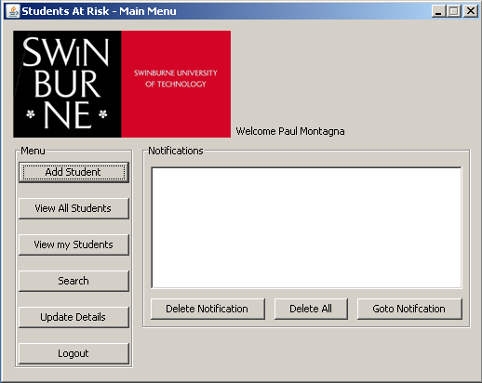

## Add Student

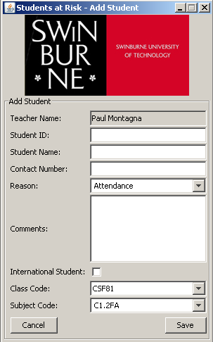

## View Student

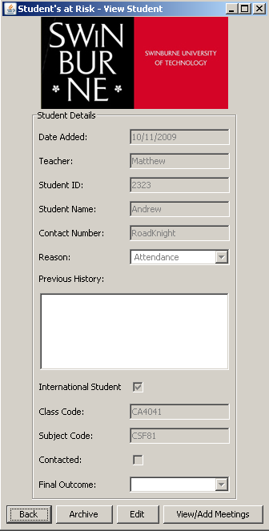

## View Students

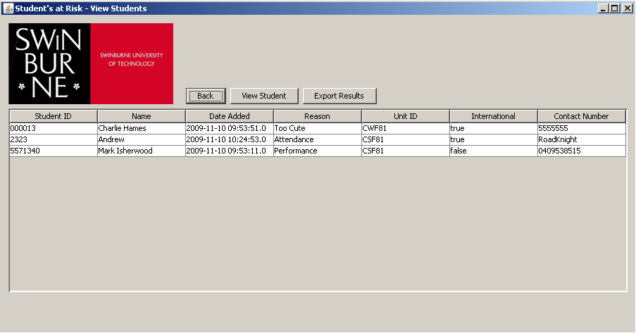

## Add Meeting

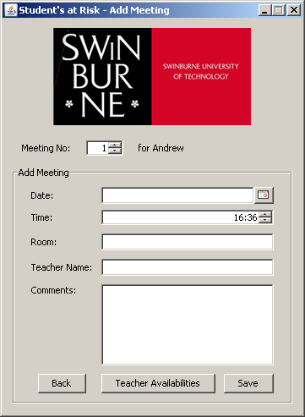

## View Meeting



Note View is the same as Add Meeting

## Teacher View



## Change Teacher Details

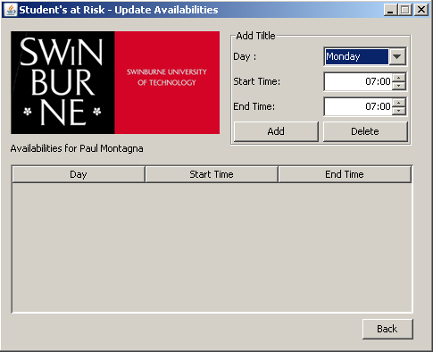

## Custom Search

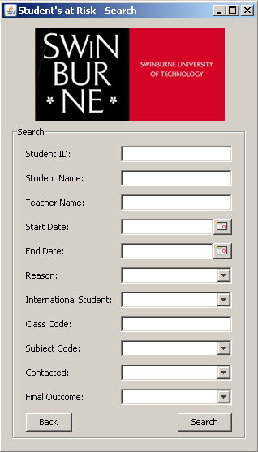

# Overview of Current System

## Overview

The current system seeks to identify students at risk and contact them to offer assistance and/or address any problems they may be having. There is evidence to suggest that the earlier a student is identified as at risk and contact is made the more likely a student will continue their studies.

## Difficulties with Current System

* Teacher input into the database is all manual
* Manual tracking of student
* The system behind the process is seen as the problem, not the process
* System has a problem with multiple users

# Conclusion

This Requirements Analysis Document has broken down the software requirements to aid in the writing of the code for the project. It has implemented; Use Case Descriptions, Use Case Diagrams, System Sequence Diagrams and a Data Domain Diagram. There are a number of prototypes, GUI’s (graphical user interfaces), to help picture the interface for the CAESAR system.

1. System Sequence Diagram. (2009, August 17). In *Wikipedia, The Free Encyclopedia*. Retrieved 02:16, August 17, 2009, from <http://en.wikipedia.org/w/index.php?title=System_Sequence_Diagram&oldid=308403866>