|  |  |
| --- | --- |
|  | |
| CAESAR-logo.png | |
| System Requirements Specification | |
| Version: 1.1  12/11/2009 | |
|  | |
| **Authors:** | **Reviewers:** |
| Matthew Close | Jamie Stevens |
|  | George Ng |
|  | Mark Isherwood |
|  | Paul Hames |
|  | Paul Montagna |
|  |  |

|  |
| --- |
|  |

# Executive Summary

This document outlines the System Requirements Specification for the Students at Risk Project.

The content contained in this document is designed to represent the requirements as understood by CAESAR (Coordinated Assistant Enterprises Students at Risk) and define the boundaries of the project.

The intended audience is our client Swinburne and the CAESAR Team.

Table of Content

Executive Summary 2

1 Introduction 5

1.1 Purpose 5

1.2 Document Scope 5

1.3 System Overview 5

1.4 Applicable Documents 5

2 General Description 6

2.1 Product Perspective 6

2.2 Product Functions 6

2.3 User Characteristics 6

2.4 General Constraints 6

2.5 Assumptions & Dependencies 7

3 Functional Requirements 8

3.1 Top Level Functional Requirements 8

3.2 Detailed Functional Requirements 9

3.2.1 UC01 Maintain Student 9

3.2.2 UC02 Maintain User 9

3.2.3 UC03 Maintain CSV 9

3.2.4 UC04 Maintain Meetings 10

3.2.5 UC05 Generate Reports 10

3.2.6 UC06 Prompt User with Updates 10

4 Interface Requirements 11

4.1 User Interfaces 11

4.1.1 Add Student 12

4.1.2 Add Meeting 13

4.1.3 Admin View 14

4.1.4 Change Teacher Details 15

4.1.5 Search 16

4.1.6 Teacher View 17

4.1.7 View Meeting 18

4.1.8 View Student 19

4.1.9 View Students 20

4.2 Hardware Requirements 20

4.3 Communications Requirements 20

4.4 Software Requirements 21

5 Non-functional Requirements 22

5.1 Usability Requirements 22

5.2 Reliability Requirements 22

5.3 Security Requirements 22

5.4 Performance Requirements 22

5.5 Technical Requirements 22

6 Acceptance Criteria 23

7 Certificate of Acceptance/Sign off 24

8 References 25

# Introduction

## Purpose

The purpose of this document is to outline the functional and non-functional requirements for the Students at Risk project.

The intended audience is our client Swinburne and CAESAR Team.

## Document Scope

System Requirements Specification document will provide the functional and non-functional requirements, user characteristics and interface requirements.

The stakeholders for the project are:

* Swinburne ICT Section of Engineering Department
* CAESAR Team

## System Overview

The system will be required to import a CSV file from the ‘Allocate+’ attendance system and update the Students at Risk database. It will also be required to monitor a student that has been flagged as at risk.

## Applicable Documents

Information pertaining to the System Requirements Specification document can be further clarified by referring to the documents listed below:

* Scope Document
* Feasibility Report
* Functional Requirements Document

# General Description

## Product Perspective

CAESAR Team is developing a software application for monitoring Students at Risk at Swinburne.

Software application should mainly focus on the following:

* Importing CSV File containing students at risk
* Manually adding students at risk by teachers
* Monitor students once they are in the system

## Product Functions

The following are the main functional requirements of the Students at Risk system:

* Maintain Student
* Import CSV file
* Maintain User
* Maintain meeting
* Generate reports
* Prompt user with updates

## User Characteristics

The two actors within the system will be; administration and users (teachers and team leaders). They should have a reasonable IT background and should not have any problems operating the system. This means a user manual is not required but a help function will be included in the system.

An administrator will be able to import a CSV file and the system will be used most days by users and administration.

## General Constraints

* The language used to develop the software must be compatible with Swinburne systems
* The end product must meet all the requirements of the client
* Time
* Resources

## Assumptions & Dependencies

* Client has the required hardware.
* Client will provide a suitable server capable of running the software solution.
* Attendance data received in a machine-readable format, e.g. CSV file, comma or tab delimited format.
* Client will provide information and assistance as required.
* The end users will be capable of using the system

# Functional Requirements

## Top Level Functional Requirements

|  |  |  |
| --- | --- | --- |
| **Use Case #** | **Name** | **Description** |
| UC01 | Maintain Student | The functions related to adding and maintaining the student at risk |
| UC02 | Maintain User | The functions related to maintaining the users of the system |
| UC03 | Maintain CSV File | The functions related to uploading the CSV file |
| UC04 | Maintain meetings | The functions related to the meetings |
| UC05 | Generate reports | All reports required by the system |
| UC06 | Prompt users with updates | Prompt teachers/team leaders to record the outcome of meetings if they have failed to do so |

## Detailed Functional Requirements

### UC01 Maintain Student

|  |  |  |
| --- | --- | --- |
| **Use Case #** | **Name** | **Description** |
| UC0101 | Add Student | Add a student to the database |
| UC0102 | Search Student | Searches the database for a student |
| UC0103 | View Student | « Extends UC012 »  Shows student information |
| UC0104 | Edit Student | « Extends UC012 »  Edits student information |
| UC0105 | Archive Student | « Extends UC012 »  Archive the student |

### UC02 Maintain User

|  |  |  |
| --- | --- | --- |
| **Use Case #** | **Name** | **Description** |
| UC0201 | Edit permissions | Change a users permissions |
| UC0202 | Add User Availability | Add User availability for meetings |
| UC0203 | Edit User Availability | Edits User availability for meetings |

### UC03 Maintain CSV

|  |  |  |
| --- | --- | --- |
| **Use Case #** | **Name** | **Description** |
| UC0301 | Import CSV File | Import CSV file into the system |

### UC04 Maintain Meetings

|  |  |  |
| --- | --- | --- |
| **Use Case #** | **Name** | **Description** |
| UC0401 | Add meeting time and location | Add time and place for meeting to student record |
| UC0402 | Record meeting outcome | Records the outcome of the meeting, gives options for proceeding with case |

### UC05 Generate Reports

|  |  |  |
| --- | --- | --- |
| **Use Case #** | **Name** | **Description** |
| UC0501 | View all students | Displays all students in system |
| UC0502 | View students by teacher | Display students for a particular student |
| UC0503 | Custom Search | This will allow the user to view a report using these selection criteria; student ID, student name, teacher name, start date, end date, reason, final outcome, international student, class code and subject code |

## 

### UC06 Prompt User with Updates

|  |  |  |
| --- | --- | --- |
| **Use Case #** | **Name** | **Description** |
| UC0601 | List of students not contacted | System will provide list of students who have not yet been contacted upon admin entering system |
| UC0602 | Prompt User to complete outstanding records | System will prompt user to fill out records for meetings which have taken place |

# Interface Requirements

## User Interfaces

The Students at Risk user interface will be of professional appearance with easy to read text. The menus will have a logical flow throughout the system.

A GUI will be provided for the system, with the look and feel selected by the CAESAR team.

### Add Student

### addStudent.png

### Add Meeting

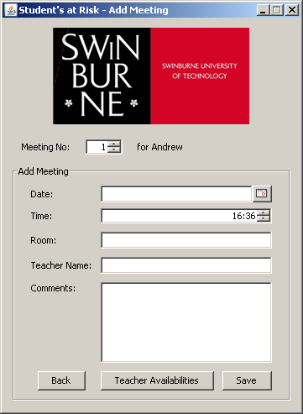

### Admin View

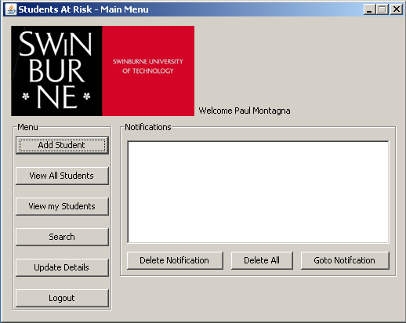

### Change Teacher Details

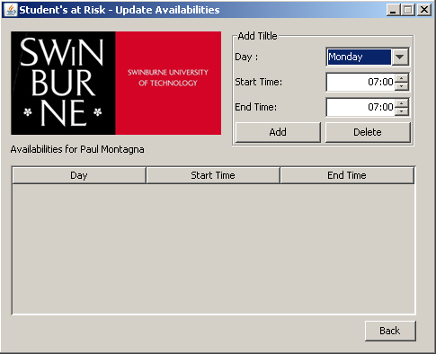

### Search

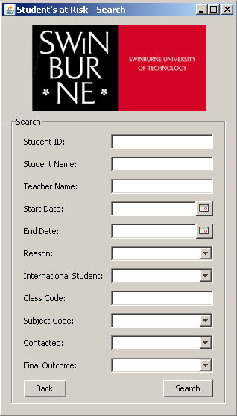

### Teacher View



### View Meeting



### View Student

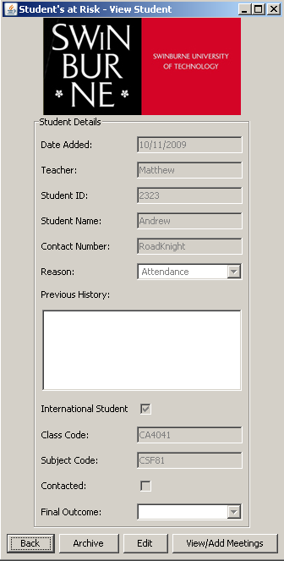

### View Students

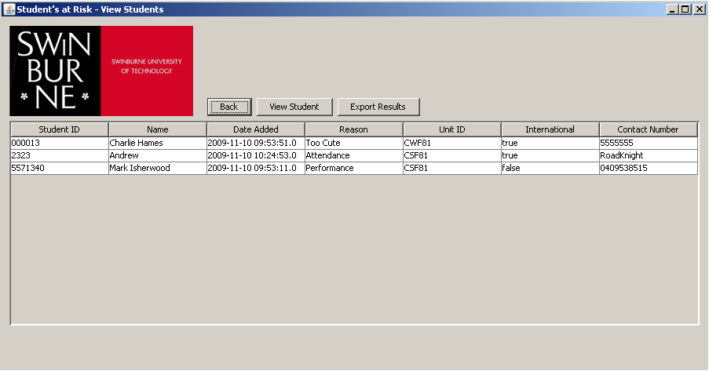

## Hardware Requirements

The following is the minimum hardware requirements to use the Students at Risk system.

* Intel Celeron D, 2.66GHz
* 512MB RAM
* Novell Network System

## Communications Requirements

The Application will be located on Swinburne servers (G drive) and the database will be stored on an existing Swinburne Server.

## Software Requirements

Students at Risk solution will be compatible with the following operating systems:

* Windows XP (Home & Professional)
* Windows Vista
* Windows 7

# Non-functional Requirements

## Usability Requirements

Follow organisation wide graphic design guidelines such as colour schemes and use of the organisations logo.

## Reliability Requirements

* Data type validation
* Appropriate error checking for fields requiring data entry and error message should be shown next to the invalid field
* System restore should ensure a minimum loss of data occurs when system recovery is required.

## Security Requirements

* Login will be provided by existing Swinburne Log in system.
* System administrator shall be able to assign user access levels

## Performance Requirements

* The system should allow for all staff to connect concurrently to the database without degrading system performance
* System response time should be adequate to perform all required
* Data operations with minimum latency

## Technical Requirements

* Software application should run on existing Swinburne hardware.
* The developed concept should be able to function on all computers that are located at Swinburne.

# Acceptance Criteria

To be accepted by the client, the software system produced by CAESAR Team must meet the requirements stated in sections 3, 4 and 5.

# Certificate of Acceptance/Sign off

The signatures below certify that the project, based upon the requirements for the Students at Risk system, has been approved and is to be undertaken by the CAESAR Team.

Client: Anna Longo

Signature: Date:

Team Mentor: Andrew Roadknight

Signature: Date:

Team Leader: Matthew Close

Signature: Date:

# References

Swinburne Major Projects – previous years